**Comprehensive Report on History App, Design Considerations, and Utilization of GitHub Actions**

1. Introduction:

The History App represents a significant endeavor in the realm of digital education, offering users a comprehensive platform to explore and understand various historical events, figures, and cultural phenomena. This report aims to provide an in-depth analysis of the app's purpose, design considerations, and the integration of GitHub Actions to streamline development and deployment processes. By elucidating these aspects, we can appreciate the significance of the app in fostering historical literacy and engagement among users.

2. Purpose of the History App:

The primary purpose of the History App is to serve as an educational tool, catering to individuals with varying levels of interest and knowledge in history. In an era where digital platforms play an increasingly pivotal role in learning and knowledge dissemination, the History App aims to provide a dynamic and interactive experience that transcends traditional methods of historical education. By harnessing the power of technology, the app seeks to make history accessible, engaging, and relevant to a diverse audience.

The app's purpose can be delineated into several key objectives:

-Education and Exploration: The app provides users with a platform to explore a wide array of historical topics, ranging from ancient civilizations to modern-day events. By offering curated content in various formats, including articles, videos, images, and interactive timelines, users can delve into different aspects of history at their own pace and according to their interests.

- Promotion of Critical Thinking: History is replete with complexities, controversies, and multiple perspectives. The app endeavors to stimulate critical thinking and historical analysis by presenting diverse viewpoints on contentious issues and encouraging users to engage critically with historical narratives. Through interactive features such as quizzes, discussions, and debates, users can interrogate historical interpretations and develop a nuanced understanding of the past.

- Cultural and Social Awareness: Understanding history is essential for comprehending the cultural and social dynamics that shape contemporary society. The app illuminates connections between past events and present-day phenomena, fostering awareness of cultural heritage, societal transformations, and global interconnectedness. By contextualizing historical developments within broader socio-cultural frameworks, the app cultivates empathy, tolerance, and appreciation for diverse perspectives.

- Accessibility and Inclusivity: Recognizing the importance of accessibility and inclusivity, the app is designed to accommodate users with diverse needs, including those with disabilities or limited access to traditional educational resources. Accessibility features such as text-to-speech functionality, alternative text for images, and adjustable font sizes ensure that the app is inclusive and accessible to all users, regardless of their abilities or circumstances.

3. Design Considerations:

The design of the History App is informed by a myriad of considerations aimed at optimizing user experience, functionality, and engagement. These design principles underpin the app's architecture, interface, content organization, and interactive features, thereby shaping the overall user journey and learning experience.

- User-Centric Interface: Central to the design philosophy of the app is a user-centric interface that prioritizes ease of use, visual clarity, and intuitive navigation. The interface is meticulously crafted to minimize cognitive load and facilitate seamless interaction, enabling users to effortlessly navigate through the app's myriad features and content offerings.

- Content Organization and Curation: With an extensive repository of historical content spanning diverse epochs, regions, and themes, effective content organization and curation are paramount. The app employs a hierarchical structure that categorizes content into thematic modules, chronological timelines, geographical regions, and specialized topics. This hierarchical taxonomy facilitates content discovery and ensures that users can explore historical narratives in a structured and coherent manner.

- Multimedia Integration: Recognizing the multi-sensory nature of learning, the app integrates multimedia elements such as images, videos, audio clips, and interactive media to augment textual content. These multimedia assets serve to enrich the learning experience, foster engagement, and appeal to diverse learning modalities. From archival photographs and documentary footage to immersive virtual tours and interactive simulations, the app harnesses the power of multimedia to bring history to life in vivid detail.

- Responsive Design: In an era characterized by the proliferation of digital devices with varying screen sizes and resolutions, responsive design is indispensable. The app is designed to adapt seamlessly to a myriad of screen sizes, orientations, and devices, ensuring a consistent and optimized user experience across desktops, laptops, tablets, and smartphones. Through fluid layouts, flexible grids, and scalable media assets, the app delivers a visually compelling and accessible experience on any device.

- Engagement and Interactivity: Interactivity lies at the heart of the app's engagement strategy, fostering active learning, exploration, and participation. Interactive features such as quizzes, polls, timelines, maps, and simulations empower users to interact with historical content in meaningful ways, thereby deepening their understanding and retention. By gamifying the learning experience and incentivizing user participation, the app cultivates a sense of curiosity, discovery, and mastery.

- Accessibility and Inclusivity: Accessibility is not merely an afterthought but a core tenet of the app's design ethos. The app adheres to web accessibility standards such as the Web Content Accessibility Guidelines (WCAG), ensuring that it is perceivable, operable, understandable, and robust for users with disabilities. Accessibility features such as screen reader compatibility, keyboard navigation, high contrast modes, and text alternatives for non-text content are seamlessly integrated into the app's design, thereby enhancing its inclusivity and usability for all users.

4. Utilization of GitHub Actions:

GitHub Actions represents a paradigm shift in software development, enabling developers to automate workflows, streamline collaboration, and accelerate the pace of innovation. The History App leverages GitHub Actions as a foundational component of its development and deployment infrastructure, harnessing its capabilities to enhance productivity, code quality, and deployment reliability.

- Continuous Integration (CI): GitHub Actions is employed for continuous integration, automating the process of building, testing, and validating code changes in real-time. Whenever developers push code to the repository, GitHub Actions triggers predefined CI workflows that automatically compile the code, execute unit tests, run integration tests, and perform code quality checks. This seamless integration of CI ensures that changes are validated expeditiously and that potential issues are identified early in the development cycle, thereby enhancing code stability and reliability.

- Automated Testing: Quality assurance is paramount in software development, and automated testing is instrumental in maintaining code integrity and preventing regressions. GitHub Actions facilitates the automation of various testing workflows, including unit tests, integration tests, end-to-end tests, and code linting. By integrating testing frameworks such as Jest, Selenium, Cypress, and ESLint into CI workflows, the app ensures comprehensive test coverage and adherence to coding standards. Any deviations or failures detected during testing trigger immediate notifications and alerts, enabling developers to promptly address issues and uphold code quality.

- Deployment Automation: Deploying changes to production environments can be a complex and error-prone process, particularly in distributed systems with multiple dependencies. GitHub Actions simplifies and automates the deployment process, enabling seamless and reliable delivery of updates to production environments. Using deployment workflows orchestrated by GitHub Actions, developers can package application artifacts, provision infrastructure resources, execute deployment scripts, and monitor deployment status—all within a unified and integrated environment. Whether deploying to on-premises servers, cloud platforms, or containerized environments, GitHub Actions provides the flexibility and extensibility to accommodate diverse deployment scenarios and requirements.

- Workflow Customization: Every project has unique requirements and workflows, necessitating the flexibility to customize and tailor GitHub Actions to specific needs. The History App leverages GitHub A versatility and extensibility to configure custom workflows tailored to its development, testing, and deployment pipelines. Through the use of YAML-based configuration files, developers define workflow specifications, including triggers, jobs, steps, and dependencies. This declarative approach allows for granular control over workflow execution, enabling developers to orchestrate complex sequences of tasks and automate repetitive processes effectively. Whether integrating with third-party services, orchestrating multi-stage deployments, or implementing conditional logic, GitHub Actions provides the flexibility and extensibility to accommodate diverse workflow requirements and development scenarios.

- Collaboration and Code Review: Effective collaboration is foundational to software development, and GitHub Actions facilitates seamless collaboration and code review workflows. By integrating with GitHub's pull request mechanism, GitHub Actions automatically triggers CI workflows upon the creation or modification of pull requests, enabling developers to validate code changes and solicit feedback in real-time. Automated checks, such as code linting, unit tests, and security scans, provide immediate feedback on proposed changes, facilitating timely code review and ensuring adherence to coding standards. Moreover, GitHub Actions' integration with code review tools and communication platforms enables developers to collaborate efficiently, discuss implementation details, and address feedback within the context of pull requests.

- Version Control and Release Management: Version control is fundamental to software development, enabling developers to track changes, collaborate effectively, and manage releases. GitHub Actions seamlessly integrates with Git, the de facto standard for version control, providing native support for versioning, branching, merging, and tagging workflows. Developers can leverage GitHub Actions to automate versioning tasks, generate release notes, and manage release artifacts, streamlining the release management process and ensuring consistency across development, staging, and production environments. By automating repetitive tasks and enforcing best practices, GitHub Actions enhances version control and release management workflows, enabling developers to focus on delivering value and innovation.

5. Conclusion:

The History App represents a milestone in digital education, offering a dynamic and interactive platform for exploring and understanding history. By elucidating the app's purpose, design considerations, and utilization of GitHub Actions, this report has provided a comprehensive overview of its significance and impact. Through its commitment to educational excellence, user-centric design, and technological innovation, the History App exemplifies the transformative potential of digital platforms in fostering historical literacy, critical thinking, and cultural awareness. As the app continues to evolve and expand its reach, it holds the promise of empowering users to engage with history in profound and meaningful ways, thereby enriching their lives and contributing to the advancement of knowledge and understanding actions:

Reference List:

Websites:

[**Adolf Hiter: Rise to Power, Impact & Death | HISTORY**](https://www.bing.com/ck/a?!&&p=8809a417176dd321JmltdHM9MTcxMjI3NTIwMCZpZ3VpZD0yOWRmY2ZkZS1iMGI2LTY2NDgtMTMxOS1kZDEzYjE4MTY3YTkmaW5zaWQ9NTI1MA&ptn=3&ver=2&hsh=3&fclid=29dfcfde-b0b6-6648-1319-dd13b18167a9&psq=adolf+hitler&u=a1aHR0cHM6Ly93d3cuaGlzdG9yeS5jb20vdG9waWNzL3dvcmxkLXdhci1paS9hZG9sZi1oaXRsZXItMQ&ntb=1) **(history.com) [Accessed 05 April 2024]**

[**Osama bin Laden: Biography, Terrorist, al Qaeda Leader**](https://www.bing.com/ck/a?!&&p=96b69495e9529d20JmltdHM9MTcxMjI3NTIwMCZpZ3VpZD0yOWRmY2ZkZS1iMGI2LTY2NDgtMTMxOS1kZDEzYjE4MTY3YTkmaW5zaWQ9NTMxMg&ptn=3&ver=2&hsh=3&fclid=29dfcfde-b0b6-6648-1319-dd13b18167a9&psq=osama+bin+laden&u=a1aHR0cHM6Ly93d3cuYmlvZ3JhcGh5LmNvbS9jcmltZS9vc2FtYS1iaW4tbGFkZW4&ntb=1) **(biography.com) [Accessed 05 April 2024]**

[**Steve Jobs | Biography, Education, Apple, & Facts | Britannica**](https://www.bing.com/ck/a?!&&p=2c8d5a33fcb7eadbJmltdHM9MTcxMjI3NTIwMCZpZ3VpZD0yOWRmY2ZkZS1iMGI2LTY2NDgtMTMxOS1kZDEzYjE4MTY3YTkmaW5zaWQ9NTI4OA&ptn=3&ver=2&hsh=3&fclid=29dfcfde-b0b6-6648-1319-dd13b18167a9&psq=steve+jobs&u=a1aHR0cHM6Ly93d3cuYnJpdGFubmljYS5jb20vYmlvZ3JhcGh5L1N0ZXZlLUpvYnM&ntb=1) **(Britannica.com) [Accessed 05 April 2024]**

[**Biography of Pablo Escobar, Colombian Drug Kingpin**](https://www.bing.com/ck/a?!&&p=a2e856205901df6bJmltdHM9MTcxMjI3NTIwMCZpZ3VpZD0yOWRmY2ZkZS1iMGI2LTY2NDgtMTMxOS1kZDEzYjE4MTY3YTkmaW5zaWQ9NTM0Nw&ptn=3&ver=2&hsh=3&fclid=29dfcfde-b0b6-6648-1319-dd13b18167a9&psq=Pablo+Escobar&u=a1aHR0cHM6Ly93d3cudGhvdWdodGNvLmNvbS9iaW9ncmFwaHktb2YtcGFibG8tZXNjb2Jhci0yMTM2MTI2&ntb=1) **(thoughtco.com) [Accessed 05 April 2024]**

[**The real-life rise and fall of Griselda Blanco—cocaine ‘godmother’ …**](https://www.bing.com/ck/a?!&&p=3ffa3e771b57b789JmltdHM9MTcxMjI3NTIwMCZpZ3VpZD0yOWRmY2ZkZS1iMGI2LTY2NDgtMTMxOS1kZDEzYjE4MTY3YTkmaW5zaWQ9NTI3MA&ptn=3&ver=2&hsh=3&fclid=29dfcfde-b0b6-6648-1319-dd13b18167a9&psq=griselda+blanco&u=a1aHR0cHM6Ly93d3cubmF0aW9uYWxnZW9ncmFwaGljLmNvbS9oaXN0b3J5L2FydGljbGUvZ3Jpc2VsZGEtYmxhbmNvLW1pYW1pLWNvY2FpbmUtNzBz&ntb=1) **(nationalgeographic.com) [Accessed 05 April 2024]**

[**Nelson Mandela - Biography**](https://www.bing.com/ck/a?!&&p=5e2dec09d5638d6bJmltdHM9MTcxMjI3NTIwMCZpZ3VpZD0yOWRmY2ZkZS1iMGI2LTY2NDgtMTMxOS1kZDEzYjE4MTY3YTkmaW5zaWQ9NTQxMg&ptn=3&ver=2&hsh=3&fclid=29dfcfde-b0b6-6648-1319-dd13b18167a9&psq=nelson+mandela&u=a1aHR0cDovL3d3dy5tYW5kZWxhLmdvdi56YS9iaW9ncmFwaHkv&ntb=1) **(mandela.gov.za) [Accessed 05 April 2024)**

[**Mahatma Gandhi Biography - Facts, Life History, Role …**](https://www.bing.com/ck/a?!&&p=c184874d2c97fec0JmltdHM9MTcxMjI3NTIwMCZpZ3VpZD0yOWRmY2ZkZS1iMGI2LTY2NDgtMTMxOS1kZDEzYjE4MTY3YTkmaW5zaWQ9NTQ1Mw&ptn=3&ver=2&hsh=3&fclid=29dfcfde-b0b6-6648-1319-dd13b18167a9&psq=mahatma+gandhi&u=a1aHR0cHM6Ly93d3cuY3VsdHVyYWxpbmRpYS5uZXQvaW5kaWFuLWhpc3RvcnkvbW9kZXJuLWhpc3RvcnkvbWFoYXRtYS1nYW5kaGkuaHRtbA&ntb=1) **(culturalindia.net) [Accessed 05 April 2024]**

[**Albert Einstein: Biography, Physicist, Nobel Prize Winner**](https://www.bing.com/ck/a?!&&p=d772a138f26de2b7JmltdHM9MTcxMjI3NTIwMCZpZ3VpZD0yOWRmY2ZkZS1iMGI2LTY2NDgtMTMxOS1kZDEzYjE4MTY3YTkmaW5zaWQ9NTMxMA&ptn=3&ver=2&hsh=3&fclid=29dfcfde-b0b6-6648-1319-dd13b18167a9&psq=albert+einstein&u=a1aHR0cHM6Ly93d3cuYmlvZ3JhcGh5LmNvbS9zY2llbnRpc3RzL2FsYmVydC1laW5zdGVpbg&ntb=1) **(biography.com) [Accessed 05 April 2024]**

[**Nikola Tesla | Biography, Facts, & Inventions | Britannica**](https://www.bing.com/ck/a?!&&p=10ceb0b78e91bac2JmltdHM9MTcxMjI3NTIwMCZpZ3VpZD0yOWRmY2ZkZS1iMGI2LTY2NDgtMTMxOS1kZDEzYjE4MTY3YTkmaW5zaWQ9NTIxOA&ptn=3&ver=2&hsh=3&fclid=29dfcfde-b0b6-6648-1319-dd13b18167a9&psq=nikola+tesla&u=a1aHR0cHM6Ly93d3cuYnJpdGFubmljYS5jb20vYmlvZ3JhcGh5L05pa29sYS1UZXNsYQ&ntb=1) **(britannica.com) [Accessed 05 April 2024]**

[**Life of Thomas Alva Edison | Biography | Articles and Essays ...**](https://www.bing.com/ck/a?!&&p=ee7329c2c2204125JmltdHM9MTcxMjI3NTIwMCZpZ3VpZD0yOWRmY2ZkZS1iMGI2LTY2NDgtMTMxOS1kZDEzYjE4MTY3YTkmaW5zaWQ9NTQ0MA&ptn=3&ver=2&hsh=3&fclid=29dfcfde-b0b6-6648-1319-dd13b18167a9&psq=Thomas+Edison&u=a1aHR0cHM6Ly93d3cubG9jLmdvdi9jb2xsZWN0aW9ucy9lZGlzb24tY29tcGFueS1tb3Rpb24tcGljdHVyZXMtYW5kLXNvdW5kLXJlY29yZGluZ3MvYXJ0aWNsZXMtYW5kLWVzc2F5cy9iaW9ncmFwaHkvbGlmZS1vZi10aG9tYXMtYWx2YS1lZGlzb24v&ntb=1) **(loc.gov) [Accessed 05 April 2024]**

[**GitHub - Wikipedia**](https://www.bing.com/ck/a?!&&p=7a713b9f0e7c7c0dJmltdHM9MTcxMjI3NTIwMCZpZ3VpZD0yOWRmY2ZkZS1iMGI2LTY2NDgtMTMxOS1kZDEzYjE4MTY3YTkmaW5zaWQ9NTMwOQ&ptn=3&ver=2&hsh=3&fclid=29dfcfde-b0b6-6648-1319-dd13b18167a9&psq=github&u=a1aHR0cHM6Ly9lbi53aWtpcGVkaWEub3JnL3dpa2kvR2l0SHVi&ntb=1) **(en.wikipedia.org) [Accessed 05 April 2024]**

[**https://youtu.be/eZXVo3vmiAU**](https://youtu.be/eZXVo3vmiAU) **-Screen Recording of History App**

Adolf Hitler

Steve Jobs

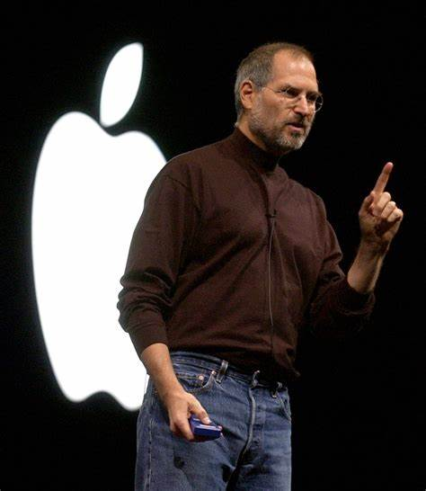

Griselda Blanco



Pablo Escobar

Nelson Mandela

Mahatma Gandhi



Albert Einstein



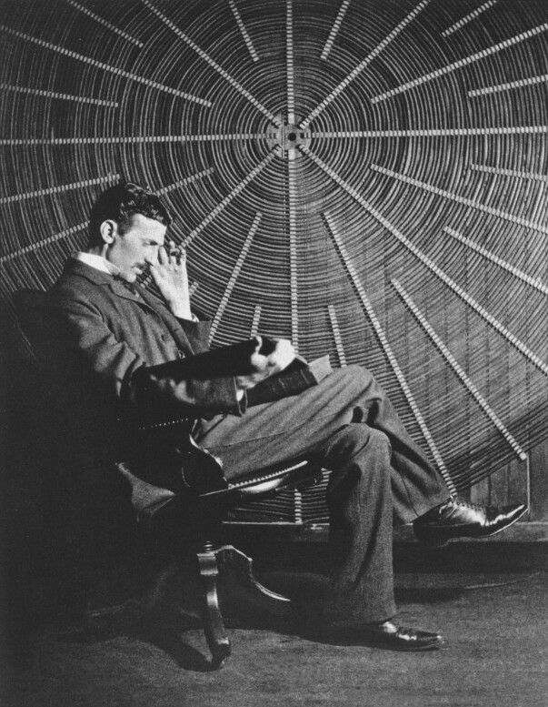Nikola Tesla

Thomas Edison

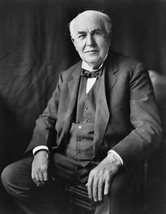

Osama bin Laden